**Lesson 6. Andreu Mut Portes L1G1**

* Today’s lesson activities will be done autonomously while I call you to do the speaking practice with me.
* Do the activities on this document and upload it on POLIFORMAT – TAREAS.
* Deadline: During today’s class time

**Practice 6 – The future of computing**

**PART 1**

**Listening – (This task will be part of your evaluation)**

You’re going to hear a talk about **artificial intelligence (AI).** You will hear the talk twice. The first time, just listen. Try to understand generally what the speaker is talking about.

The task will play once

She speaks about AI, she makes a quick description about what it is, then she gives some examples about where we can use AI. Finally she finishes speaking about some advantatges and disadvantages.

**Can you tell me in one or two sentences what the speaker was talking about?**

Now listen to the talk again. This time make some notes as you listen. Then I’ll ask you to tell me what the speaker says AI **CAN DO** and what the speaker says AI **CANNOT DO**. Try to make notes on as many examples as you can. Are you ready?

The task will play once.

✓

Radiologists know the tumors

,Astronomists discover exoplanets,

Used for parking

Prevent Climate changes

New Jobs Will be created and Will have more quality.

✘

Need a lot of data.

Some Jobs Will be removed because tasks will be automated

Affect social groups.

It is hard this technology.

**Now write down what the speaker says AI can and cannot do.**

Record a **1.5-MINUTE FLIPGRID** in which you tell me what AI can and cannot do according to the recording and give your opinion on whether AI will improve our society or not. I’ll stop you after one minute and a half.

**PART 2**

**1. Watch this TED talk video by Dr. Suwajanakorn titled *Fake videos of real people – and how to spot them* at:**

[**https://www.ted.com/talks/supasorn_suwajanakorn_fake_videos_of_real_people_and_how_to_spot_them#t-74687**](https://www.ted.com/talks/supasorn_suwajanakorn_fake_videos_of_real_people_and_how_to_spot_them#t-74687)

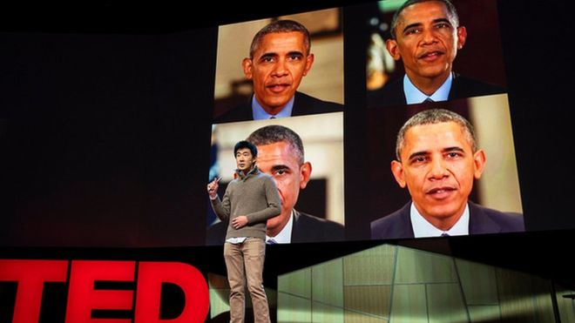

**2. Now read this article from the BBC** [**https://www.bbc.com/news/technology-43639704**](https://www.bbc.com/news/technology-43639704)

**TED 2018: Fake Obama video creator defends invention**

By Jane Wakefield, Technology reporter - 13 April 2018

Bret Hartman/TED. None of these Obama videos is real said Supasorn Suwajanakorn

A researcher who created a fake video of President Obama has defended his invention at the latest TED talks. The clip shows a computer-generated version of the former US leader mapped to fit an audio recording. Experts have warned the tech involved could spark a "political crisis".

Dr Supasorn Suwajanakorn acknowledged that there was a "potential for misuse".

But, at the Vancouver event, he added the tech could be a force for good. The computer engineer is now employed by Google's Brain division. He is also working on a tool to detect fake videos and photos on behalf of the AI Foundation.

**Damage risk**

Dr Suwajanakorn, along with colleagues Steven Seitz and Ira Kemelmacher-Shlizerman from the University of Washington, [released a paper](http://grail.cs.washington.edu/projects/AudioToObama/siggraph17_obama.pdf) in July 2017 describing how they created the fake Obama. The tool can edit videos of people speaking and make them say something they have not. They developed an algorithm that took audio and transposed it on to a 3D model of the president's face. The task was completed by a neural network, using 14 hours of Obama speeches and layering that data on top of a basic mouth shape.

Dr Suwajanakorn acknowledged that "fake videos can do a lot of damage" and needed an ethical framework. "The reaction to our work was quite mixed. People, such as graphic designers, thought it was a great tool. But it was also very scary for other people," he told the BBC.

**Political crisis**

It could offer history students the chance to meet and interview Holocaust victims, he said. Another example would be to let people create avatars of dead relatives.

Experts remain concerned that the technology could create new types of propaganda and false reports.

"Fake news tends to spread faster than real news as it is both novel and confirms existing biases," said Dr Bernie Hogan, a senior research fellow at the Oxford Internet Institute.

"Seeing someone make fake news with real voices and faces, as seen in the recent issue about deepfakes, will likely lead to a political crisis with associated calls to regulate the technology."

Deepfakes refers to the recent [controversy over an easy-to-use software tool](http://www.bbc.co.uk/news/technology-42984127) that scans photographs and then uses them to substitute one person's features with another. It has been used to create hundreds of pornographic video clips featuring celebrities' faces.

Dr Suwajanakorn said that while fake videos were a new phenomenon, it was relatively easy to detect forgeries.

"Fake videos are easier to verify than fake photos because it is hard to make all the frames in video perfect," he told the BBC.

"Teeth and tongues are hard to model and could take another decade," he added.

The researcher also questioned whether it made sense for fake news creators to make complex videos "when they can just write fake stories".

**3. In the article from the BBC, Dr. Suwajanakorn says that this technology “could be a force for good”. However, one of the comments posted on the video channel says: “An extremely dangerous technology. It WILL be misused. The cat is out of the bag now, though.”**

**Which statement do you agree with? Write a short paragraph giving reasons (10 -15 lines).**

I am not completely agree or disagree with any of them. This technology may have advantages and disadvantages like everything. I am agree that fake news are something that we have around us nowadays and the misinformation is important for some groups to direct people into their ideas but, like Dr. Suwajanakorn said, nowadays, it is hard to model teeth or the tongue, so fake videos are easily recognized, not like fake pictures. And that is why we have to be critics about what we see and contrast all the information we get in different resources. I am disagree with Dr. Suwajanakorn when he says that with this technology we can speak with Holocaust victims or dead relatives, I think we should not speak with deaths. An alive person can give us a lecture about a topic perfectly, we do not need to recreate Holocaust victims, this is my opinion. If this technology has a future, we will see, but I do not find it useful nowadays according to what he said.

**Speaking Topic 6**

**2. Work in groups. The future of computing: how do you imagine the world of computing in the future? Here you have some ideas, you can use your own ideas as well! Be imaginative! ☺**

Use guessing structures:

I suppose…

I guess…

Perhaps…

We might be using…

We may use…

|  |  |
| --- | --- |
| Imagen relacionada  Electronic skin | Resultado de imagen de virtual reality  Virtual reality |
| Imagen relacionada  Wearable technology | Imagen relacionada  Artificial intelligence |

Use future tenses

- We are going to do

- We will do

- We will be doing

- We will have done